**Action items based on CollegeDunia Data**

Out of the total 1,49,992 users originating from within India, 238 have successfully enrolled in a course making **lead conversion rate = 0.16%** (where enrolment = “Yes”)

**Short term action items:**

* 619 leads out of 1,49,992 leads originating from within India and active in past year, have lead stage at “Application Submitted”

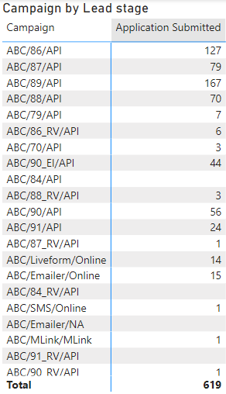

* 15 leads out of 619 **(2.42%)** who have **submitted form** in the past 16 months (from May 2023) have still not paid or got enrolled in a course.
* 381 leads out 619 **(61.55%)** who have **submitted form and paid** in the past 16 months (from May 2023) have still not got enrolled in a course.
* Focus should be on these leads (15 + 381) to find the reasons for their non-enrolment and check with the relevant course provider college.
* In the **past 3 months** (before May 2023), 3 leads have submitted form and paid but have not been enrolled in a course. Also, in past 3 months 2 have initiated filling a form and have not paid or enrolled in a course.

Focus should be on these leads since are would be currently activity seeking admission into a course.

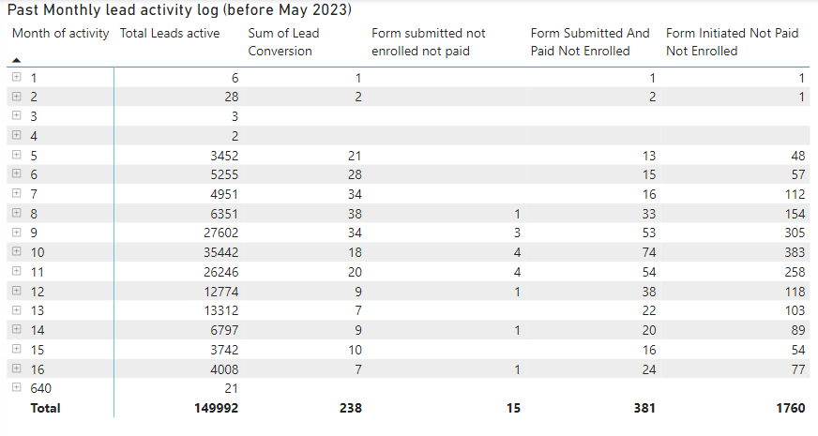

* **1760** leads **have initiated** filling a form however they have not paid nor enrolled in a course.

These require to be reached out for finding reason for their non-enrolment and monitored for any assistance.

**Long term action items:**

**State wise analysis:**

* Overall, the highest number of leads were from Karnataka (49,171), followed by Tamil Nadu (17,642) and Andhra Pradesh (13,424)
* Southern states combined account for 60.89% of total leads but have lower lead conversions

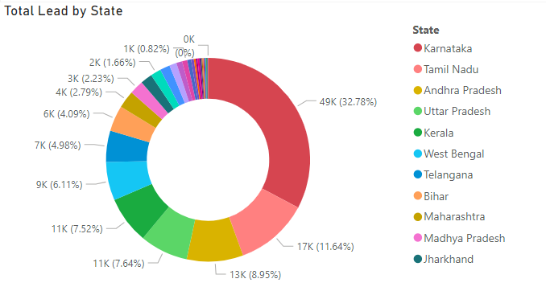

* At 1.22% Nagaland has the highest lead conversion percentage. Higher lead conversion rates are observed for **north-eastern and Hill states** like Manipur, Himachal Pradesh, J&K and Assam.

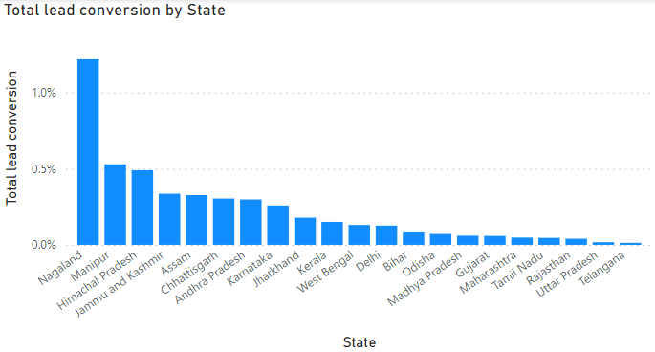

Company has to focus on these geographies as it would lead to higher revenues from lead generation and conversion.

* Focus should be **on market entry strategies** for northern and north-eastern states having good lead conversion rates and on **improving campaigns (API/Online)** for southern states for increasing lead conversion.

**Course analysis:**

* Highest number of leads look out for **B. Tech** courses (55,551) followed by **MBA** (23647) and **B. Com** (15009)
* Lead conversion has been highest for **BA-Journalism** at 0.79%, followed by BBA (0.51%) and B. Des, BCA each at 0.25%
* **B. Tech** and **MBA** combined account for **52.79%** of total leads and their conversion rates are lower at 0.15% and 0.16% respectively
* **B.Tech, BBA, BCA, B.Com, MBA** have 1433 leads having initiated filling form accounting for **81.11%** out of total 1765 of those filling forms**.**

This shows higher interest in these courses requiring more focus for implementing lead acquisition strategies for these courses.

**Campaign wise analysis:**

1. Most of the campaigns have been for **B.Tech** courses (55551), followed by MBA (23647) and B.Com (15009)

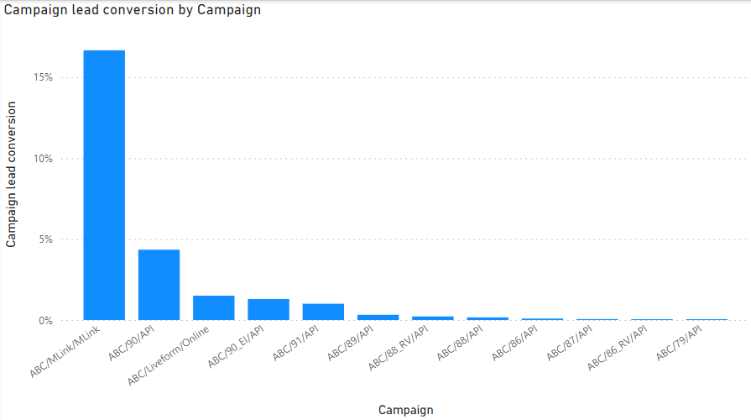

1. Highest overall campaign lead conversion rate has been for ABC/Mlink/Mlink at 16.67%

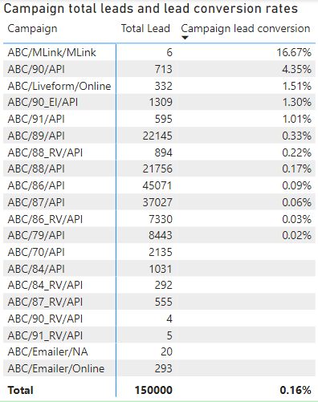

1. Course wise campaign lead conversion rate have been:
   1. B. Tech – ABC/90/API at 6.76%
   2. MBA – ABC/91/API at 3.90%
   3. BCA – ABC/90_EI/API at 3.76%

**Lead origin Analysis:**

* Online Lead conversion at 84.75% is better than lead conversion through API at 15.25%
* Focus should be to reach leads more through Online based campaigns than API

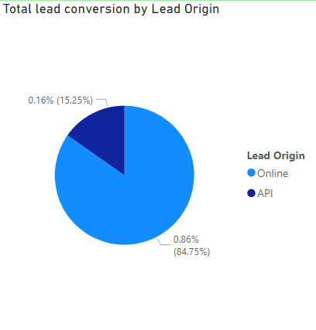

**Lead Stage Analysis:**

* **Half** of all the leads are in the **untouched** stage **(49.52%)**

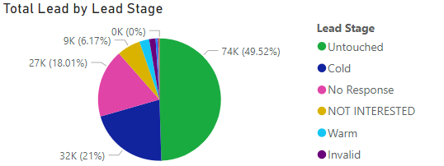

* **96.83%** of all leads are **not** in application submitted, warm or hot stages. That means they are either not responding, not interested, cold, invalid, rejected or untouched.

**\*(Please refer the Power BI report – Shourya Singh analysis.pbix for detailed visuals)**